CLERKS REPORT
SEPTEMBER 2020

- Scout Hut/Cricket Pavilion Legal agreements
  - The working party continue to work with Chandler Ray Solicitors to set out the legal position of Maids Moreton Parish Council and 1st Maids Moreton Scout Group Council/Maids Moreton Cricket Club in relation to the updating and replacement of their legal agreements.
  - Approximate cost for legal work has been quoted as £1,000 for both legal agreements, which is being split equally between the 2 buildings at £500 each.
  - 1st Maids Moreton Scout Group Council are in breach of their contract as they have not maintained the building in a state of good repair. A meeting has been requested with 1st Maids Moreton Scout Group Council to discuss a new legal agreement.
  - Maids Moreton Cricket Club License has expired and needs to be renewed. Once the agreement is in place for 1st Maids Moreton Scout Group Council, a new license needs to be agreed between Maids Moreton Parish Council and Maids Moreton Cricket Club.
- Website – we have been allocated a specific contact within TEEC Ltd and have use of the support ticketing system.
  - JDE has chased the following queries with individual councillors:
    - GM was set up, but something has gone wrong and it is now not working. Ongoing, JDE to help.
    - AM address has been set up incorrectly and this is waiting to be amended. Awaiting information from AM.
    - MB has attempted to set his up several times and is not yet up and running.
All have been asked to refer this to TEEC through their support ticketing system.
Option of paid support on the agenda.
- Handyman – Andy Gibbs
  - Removing all signs citing legal powers to keep dogs off the playing field – in progress.
  - Continuing to keep the MVAS batteries charged.
- Ad Hoc Work Completed by external contractors
  - Woodard bollards installed by GM Outdoor Services at the 2nd entrance to the park.
  - Aylesbury Main repair to Light 1, on Towcester Rd/Scotts Farm Close – broken lantern diffuser from high winds.
  - Aylesbury Main repair to light 43 on Manor Park, replace photcell and HR fuse.
  - Acme Pest Control removal of wasp nest from under the Scout Hut.
- Maids Moreton Parish Action Plan
Nothing to report.
- Dogs on Playing Fields.
  - Signs to be removed from playing field.
  - Confirmation from BC that our Dog Control Order and all quoted legislation are no longer valid. They are investigating a possible PSPO but this is thought not possible as the land is privately owned by MMPC.
- Scout Hut Lease – information on current lease agreement and deed of gift sourced. Meeting requested with scout leadership team.
- MVAS Speed Sign – I am investigating the capabilities of the MVAS with Swarco Ltd. I do not believe this currently has the ability to store any data. I think it is just a sign that is activated by speeding motorists. I cannot find any bluetooth capability for downloading any data. A bluetooth dongle is in the region of £200. Further investigations with both Swarco and a local company Traffic Technology are ongoing.
- Community Right to Bid – application submitted on 1/10/2020.
- New bollards - Mr Geoff Brandon, who lives at the end of the 2nd entrance to the park, is not in favour of the new wooden bollards that have been installed to prevent vehicles from driving over the grass, making a mud patch on the edge of this verge. He suggests that these wooden boundaries would prevent access for emergency vehicles should they need to drive down the lane. Item 187/20 on the agenda.
I have spoken to the Buckinghamshire Fire Service and emailed pictures over. They have also done a site visit. They are happy with the new boundary markers and do not feel they would impede their response to an emergency.
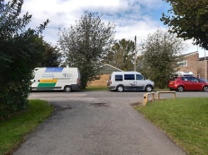
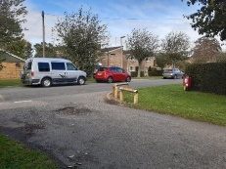
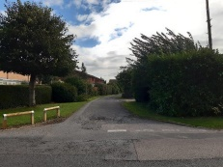
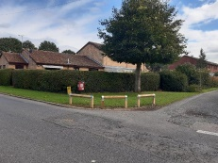
Pictures here:
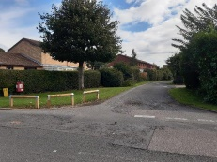
- Outstanding Quotes:
  - Playing Fields Carpark pothole repairs – CJM Fencing. I have met with CJM Fencing and agreed 15 deep potholes that will be repaired. All other areas are not deemed to be deep enough to need repair at this time. Planned for Sept 2020. Chased with CJM Fencing. They are still having trouble sources materials. They will let me know when they are ready to complete. Chased for information 02/10/2020.
  - Remedial work to footpaths in park to be carried out by CJM Fencing. I have had a site meeting with CJM Fencing. Remedial works are to be completed Sept 2020 or before if possible. To be completed with carpark repair. Chased for information 02/10/2020.
  - Siting of picnic benches at playing field. To be completed ASAP. Site visit with GM Outdoor Services carried out. Chased for information 02/10/2020.
- Planning
  - Existing Planning Awaiting Decision
Application Number | Details | Progress
20/02612/APP | Foscote Hill Farm Foscote Road Maids Moreton Buckinghamshire MK18 1QQ.  Relocation of a farm business to include temporary residential accommodation for a period of three years and construction of agricultural buildings.  Commented – Supported. | Awaiting Decision.
20/02464/APP | Red House Nursing Home Main Street Maids Moreton Buckinghamshire MK18 1QL  Retention of timber side extension  Commented – Supported. | Awaiting Decision

  - Existing Planning – Decided
Application Number | Details | Progress
CC/0035/20  (Minerals and Waste Website not Planning.) | Maids Moreton Church Of England School Avenue Road Maids Moreton MK18 1QA  Proposed front and rear single storey extensions and external alterations to include extension to play area to existing school.  Commented – Supported.  New application for approval of details pertaining to conditions 3 (Surface Water Drainage) and 6 (Great Crested Newt – Delivery Partner Certificate) of planning permission CC/0035/20 22/09/2020. | Application Permitted.  04/09/2020

  - Existing Planning – Long term
Application Number | Details | Progress
18/01385/AOP | Land at Scotts Farm Close Information.  Approved 04/09/2020  https://www.rightmove.co.uk/commercial-property-for-sale/property-73056012.html | Land now for sale.
16/00151/AOP | Walnut Drive  Will be going back to committee later this autumn (provisionally 19 November)  S106 draft document commented on. | Going back to committee.
20/00510/APP | Land to the west of Moreton Road and Castlemilk  Erection of 130 dwellings, associated access and parking, landscaping and amenity space and the change of land from agriculture to use as sports pitches/recreational open space and informal open space.  Armstrong [for Bellway Homes Ltd. And Avenue Farms Ltd.] | Awaiting Decision

